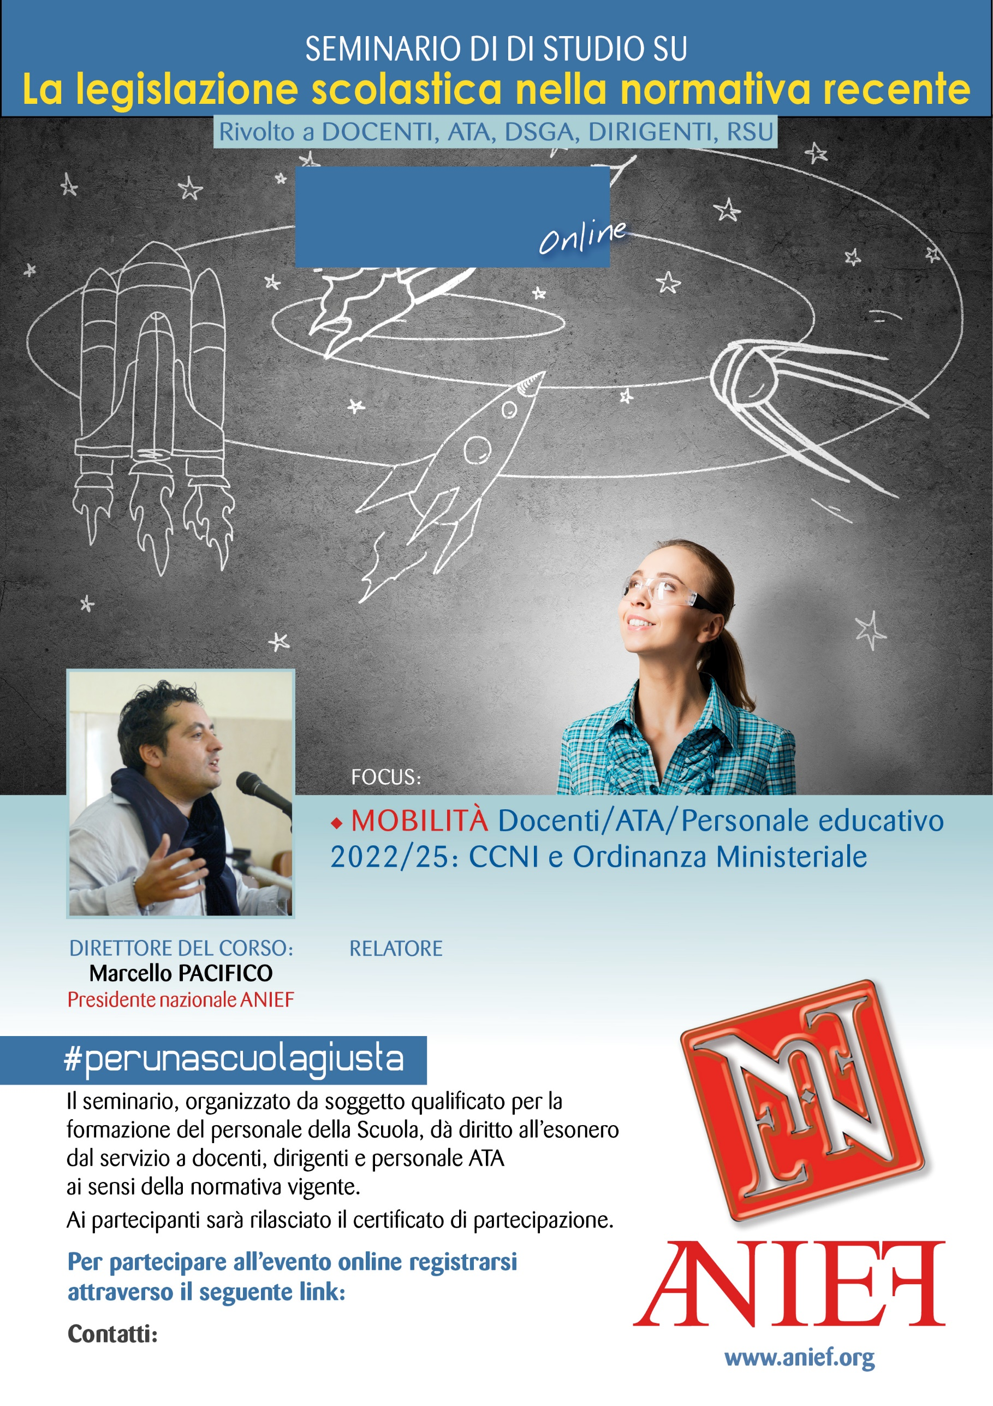
LINK DIRETTA: https://anief.org/component/anief/dettaglievento?id=75049
emiliaromagna@anief.net
FABIANA BRUNO
EMILIA ROMAGNA
11/03/2022 ORE 11:00 – 13:00

